The first one designed for worldwide and is the only one which incl. intelligent BEEP alert & best performance.

--- YOUR BEST CHOICE ---

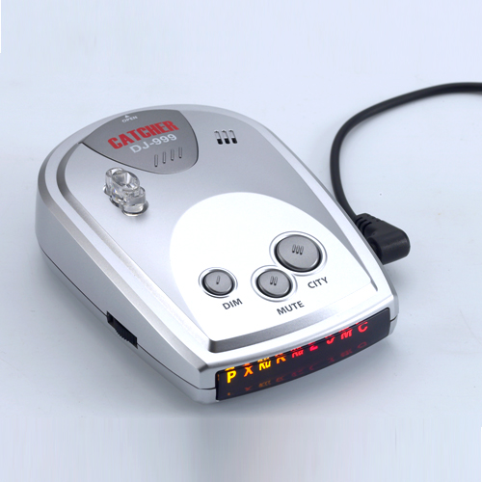

Quiet, Advanced and Versatile Ultimate Safety Radar Detector
The CATCHER DJ-999 has been optimized for use in the world. The DJ-999 includes full X, K, Ku, Superwide Ka radar system capability, front and rear LASER detection, digital signal processing (DSP) for superior range and reduced false alarms with audio and Visual band alerts. And all the performance you’d expect from DJ-999.
Features Include:
- Full band detection of all police radar/laser equipments.
- Excellent performance of GATSO Photo Radar
- Clear Text Character display and 5 different beep audio alert.
- Separated each band’s beep audio and Indicator
- Superheterodyne, GaAs FET VCO digital signal processing, Scanning Frequency Discriminator with Strength Meter indicator.
- New SpeedScan mode with virtually eliminates false alarms
- Easy mount either on the dashboard or windscreen with suction cup bracket

